* CB FSD - Integration and Deployment

Day 12 : 1 Aug 2024

Running CI and CD tool ie Jenkin on EC2 instance

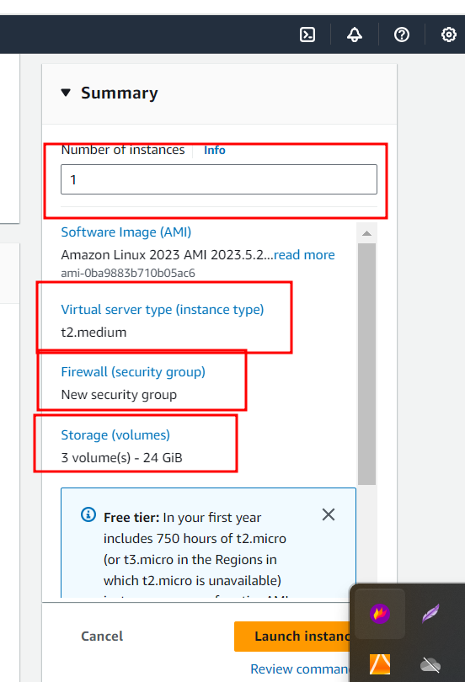

After created EC2 instance

Install the java

sudo yum install java-17

now we need to install jenkin software

1

sudo wget -O /etc/yum.repos.d/jenkins.repo <https://pkg.jenkins.io/redhat/jenkins.repo>

2

sudo rpm --import <https://pkg.jenkins.io/redhat-stable/jenkins.io-2023.key>

3

sudo service jenkins start

4

sudo service jenkins status

by default Jenkin run on port number 8080.

Please check Jenkin initial password

sudo cat /var/lib/jenkins/secrets/initialAdminPassword

course 4 end project

1. Create spring boot project with starter as web starter, Thymeleaf
2. Create simple controller that controller responsible to open index.html page.
3. Index.html page you can write Dr. Shawn runs a pet clinic.
4. Please test this project in local machine.
5. Create jar file for the project
6. Then create Dockerfile using Docker test this application in local machine.
7. Create Jenkinsfile which is responsible to build maven project.
8. Please write a command to build and run the image
9. Push this project in remote repository
10. Create EC2 instance with t2.medium
11. Then install java software, git install and install docker software.

sudo yum install java-11

sudo yum install git

sudo yum install docker

sudo service docker start

1. Install jenkin

sudo wget -O /etc/yum.repos.d/jenkins.repo <https://pkg.jenkins.io/redhat/jenkins.repo>

sudo rpm --import <https://pkg.jenkins.io/redhat-stable/jenkins.io-2023.key>

sudo service jenkins start

sudo service jenkins status

1. Create Jenkin pipe line job which is responsible to run the Jenkinsfile

-----if you want to run docker and docker-compose in jenkin then please execute these command ---------------------

sudo usermod -a -G docker jenkins

sudo usermod -a -G docker ec2-user (ec2-user is user name of instance )

sudo chmod 777 /var/run/docker.sock

sudo service jenkins restart

Creating another micro service project for product related operation

Starter 🡪 Web Starter

Starter -🡪 JPA starter

Dependency 🡪 mysql connector

Starter -🡪 Eureka discovery client

Starter 🡪devtool

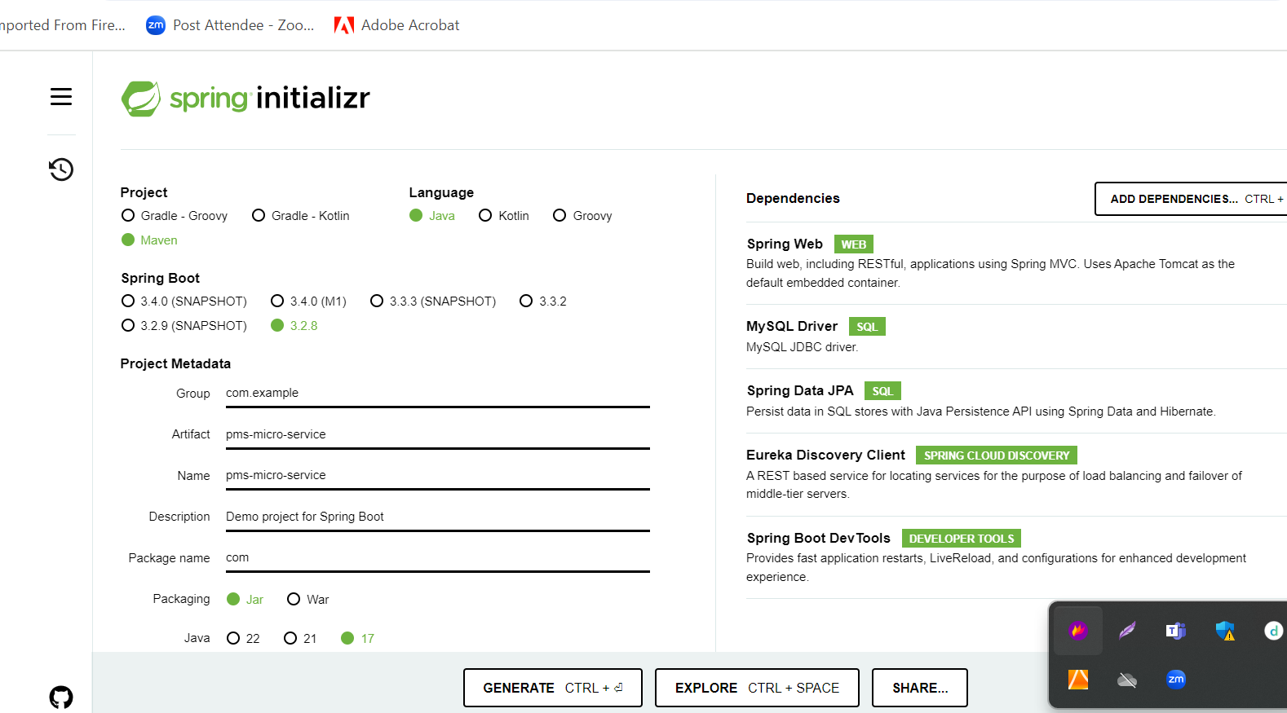

Changing column for image url using below command

**alter table product modify imageurl longblob;**